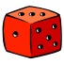
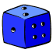

Year 11

Simulation Workbook
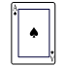
A
B
C

By Liz Sneddon

Name:

Introduction
The next few pages cover the skills you need to know for this topic.
There are some situations where we know what the theoretical probability is (e.g. tossing a coin has a 50% chance of getting a head), and other situations where we do not know what the theoretical probability is (e.g. what is the chance that the photocopier breaks down today?). We will explore both of these types of situations.
Then you will complete several simulations, which will show you what you need to do for your assessment.

Probability Tools
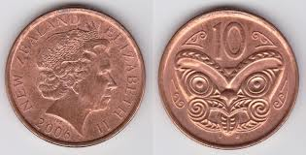
A coin:
A coin has two sides, heads and tails.

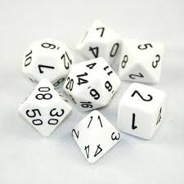
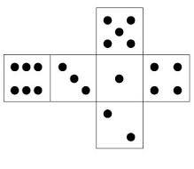
A die:
A standard die has 6 sides, with the numbers 1 – 6 on each side. You can get die with 10, 12, or other numbers of sides.

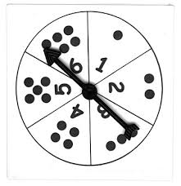
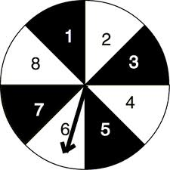
A Spinner:
A spinner is a circle that has been divided up into any number of pieces.

A pack of cards:
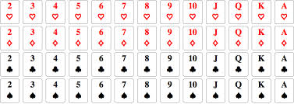

In a pack of cards there are 4 suites:
- Diamonds
- Hearts
- Clubs
- Spades

Each suite has 13 cards: Ace, King, Queen, Jack, 10, 9, 8, 7, 6, 5, 4, 3, 2
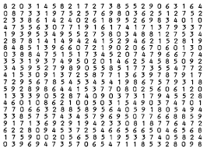
Random number generator:
Both your calculator and the sphero’s have a random number generator, which can generate a random number between 0 and 1.

Language of probability
Probability is a measure of the chance of an event happening.

It can be written as a decimal, fraction or percentage
(decimal or fraction are best)

Probabilities MUST be between 0 and 1 (inclusive)

0
1

0
.
2

0
.
3

0
.
4

0
.
5

0
.
6

0
.
7

0
.
8

0
.
9

1

0
never rare sometimes half often usually always
impossible unlikely maybe likely certain

Exercise:
QUESTION 1
Using the terms of probability, rate the following events as certain, likely, unlikely, impossible, or even chance.
- a lion having four legs
- rolling a 7 with a normal die
- choosing a black card
- Monday will follow Sunday next week
- winning Lotto (assuming you have not bought a ticket)
- throwing a tail with a coin
- rolling a 3 with a normal die
- a year having 410 days

QUESTION 2
Select the most appropriate from the probabilities below to describe the chance implied by each of the following words.
0%, 25%, 50%, 75% and 100%
- certain
- an even chance
- probably
- unlikely
- definitely
- likely
- possibly

QUESTION 3
Select from the words below to best describe an event that has a probability of the values below.
certain, most likely, even chance, unlikely, or impossible
- 90%
- 1/2
- 1
- 0
- 15%
- 100%
- 0·007
QUESTION 4
Use the following words to complete these sentences.
distribution data
frequency cumulative frequency
frequency distribution table relative frequency
frequency histogram

a) Information collected in the survey is called
b) The number of times a score occurs is called the of that score.
c) An arrangement of a set of scores is called its
d) A table that displays all information in an organised way and shows the frequency of each score is called a

e) A column graph that shows the frequency of each score is called a

g) of a score is the number of scores equal to or less than that score.
h) of a score is the ratio of the frequency of that score to the total frequency.

QUESTION 5
Use the following words to complete these sentences.
discrete data continuous data mean range
median variable mode

a) The average of a set of scores is called the
b) When the scores are arranged in order of size (ascending or descending order) the middle value is called the
c) The score that occurs the most is called the
d) The difference between the highest and the lowest scores is called the
e) Any quantity that varies is called a
f) is count data that has values that are whole numbers.
g) are measurements that can have any value in a given range.

Probabilities
To find the probability of an event
$$P\left(event\right)=\frac{number of ways it can happen}{total number of outcomes}$$

Example:
Rolling a die has the following outcomes: 1, 2, 3, 4, 5, or 6
The probability that the number 5 comes up when a die is rolled is:
$$Pr\left(5 on an die\right)=\frac{1}{6}$$

Exercise:
- A card is drawn at random from a normal pack of 52 cards. Find the probability that the card is:
- a diamond
- a red card
- a king
- not a club
- a red ace
- a 5 of clubs
- an 8

- From the letters of the word ‘PROBABILITY’, one letter is selected at random. What is the probability that the letter is:
- a vowel
- the letter P
- the letter P or B
- the letter M
- A die is thrown once. Find the probability that it is:
- a six
- an even number
- a number greater than 4
- a seven
- A bag contains 5 red, 3 blue and 2 white balls. If a ball is drawn at random, find the probability that it is:
- blue
- red
- not red
- either blue or red

Terminology

Outcome: What we could get
E.g. got a 6 rolling a die

Sample space: The list of all outcomes

Event: Something which has a number of outcomes by chance
E.g. roll a die

Trial: One repetition of an event
E.g. rolled a die once

Frequency: Number of times an event occurs

Equally likely outcomes: outcomes with the same chance

P (outcome A) = “the probability of getting outcome A is…”

Independent: not influenced by other events

Relative frequency: Probability

Exercise:
QUESTION 1
Write the sample space for each of the following.

a) selecting a day of the week

b) selecting a month of the year

c) rolling a die once

d) tossing a coin once

g) choosing a letter from the alphabet

QUESTION 2
The letters of the word MATHEMATICS are written on cards and turned face down. A card is then selected at random.
a) Write the sample space.

b) How many elements are in the sample space?

c) How many different elements are in the sample space?

QUESTION 3
For each of the following, state whether each element of the sample space is equally likely to occur.

a) tossing a coin
b) rolling a die
c) the result of a cricket game between two teams
d) selecting a card from a normal pack of cards

Tally, Frequency and Relative Frequency
A tally is recording a tally mark when you have a certain outcome in your data set.
A frequency is counting up how many times each number occurs.
Relative frequency= $\frac{Frequency of outcome}{Total number of outcomes}$

Example:
The frequency of the following numbers are:
4, 8, 3, 2, 7, 7, 8, 7, 3, 6, 5, 2, 8, 5, 4, 7, 6, 2, 3, 2
Score | Tally | Frequency | Relative Frequency
2 | |||| | 4 | 4 / 20 = 0.2
3 | ||| | 3 | 3 /20 = 0.15
4 | || | 2 | 2 / 20 = 0.1
5 | || | 2 | 2 / 20 = 0.1
6 | || | 2 | 2 / 20 = 0.1
7 | |||| | 4 | 4 / 20 = 0.2
8 | ||| | 3 | 3 / 20 = 0.15
 |  | Total = 20

Exercise:
QUESTION 1
A survey involving the test results obtained by a class of 30 students is given:
9 7 7 5 6 7 6 7 8 6 6 6 8 9 10
5 6 7 8 6 5 4 3 6 7 9 8 9 7 9

Score | Tally | Frequency | Relative Frequency
3
4
5
6
7
8
9
10

QUESTION 2
Fifty families were surveyed to find how many children each family has and the following set of data was obtained. Complete the frequency distribution table.
5 3 2 4 1 5 0 2 3 2 2 1 1 3 3 4 1
3 2 1 3 3 2 2 2 3 2 1 3 1 2 3 0 1
1 5 3 4 5 0 3 0 2 0 2 2 1 5 4 3

Score | Tally | Frequency | Relative Frequency

Frequency and Relative Frequency bar graphs
A frequency graph plots the frequency on the vertical axis and the scores or groups on the horizontal axis.
A relative frequency graph plots the relative frequency (as a decimal between 0 and 1) on the vertical axis and the scores or groups on the horizontal axis.

Example:
Score | Frequency | Relative Frequency
2 | 4 | 4 / 20 = 0.2
3 | 3 | 3 /20 = 0.15
4 | 2 | 2 / 20 = 0.1
5 | 2 | 2 / 20 = 0.1
6 | 2 | 2 / 20 = 0.1
7 | 4 | 4 / 20 = 0.2
8 | 3 | 3 / 20 = 0.15
 | Total = 20

Exercise:
QUESTION 1
A survey involving the test results obtained by a class of 30 students is summarised below. Draw both a frequency and relative frequency bar graph.

Score | Frequency | Relative Frequency
3 | 1
4 | 1
5 | 3
6 | 8
7 | 7
8 | 4
9 | 5
10 | 1

QUESTION 2
Fifty families were surveyed to find how many children each family has and the following set of data was obtained. Draw both a frequency and relative frequency bar graph.
Children | Frequency | Relative Frequency
0 | 5
1 | 10
2 | 13
3 | 13
4 | 4
5 | 5

Measures of center
There are 3 measures of center that we use:
- Mode – the most common number
- Median – the number in the middle
- Mean – add the values and divide by the sample size

Example:
Find the mode, median and mean of the data below.
3, 4, 3, 5, 3, 6, 4, 4, 3, 5, 6, 3, 4, 3, 5
Score | Frequency
3 | 6
4 | 4
5 | 3
6 | 2
 | Total = 15

Mode = the most common score is 3
Median = 4
$$Mean=\frac{3+4+3+5+3+6+4+4+3+5+6+3+4+3+5}{15}$$
$$=4.07(2dp)$$

Exercise:
QUESTION 1
Find the mode of each set of scores.
a) 4, 4, 5, 6, 6, 7, 7, 8, 7, 8
______________________________________
b) 7, 11, 11, 12, 12, 12, 12, 12 ______________________________________
c) 7, 8, 8, 7, 9, 7, 10, 11, 10, 8, 8
______________________________________
d) 47, 12, 13, 47, 48, 49, 47, 47, 48, 47 ______________________________________

QUESTION 2
Find the median of each set of scores.
a) 4, 5, 6, 7, 8
______________________________________
b) 2, 3, 3, 4, 5, 5, 6, 6, 6, 6, 7, 7 ______________________________________
c) 10, 60, 40, 20, 50, 90, 70, 80, 30
______________________________________
d) 12, 14, 11, 7, 11, 8, 13, 9, 10, 14
______________________________________

Describe the shape of the distribution
One key feature of a graph is its shape, as this gives an indication of what distribution the simulated data may be from.
We only describe the shape when there is an order to the data. E.g. test scores. But not for groups E.g. Male, Female.
The first thing you need to do is sketch a rough shape over the top of you bar graph.
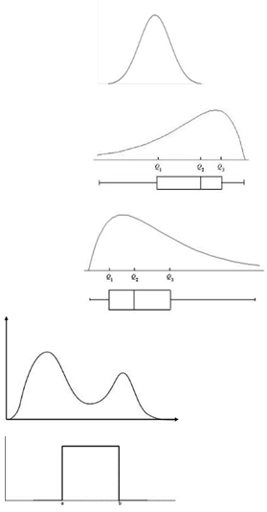
The next question you should ask yourself when analysing the shape of the distribution, is “which distribution does my data best match?”.

Normal distribution
(hill/mound shapes, symmetric, bell shaped curve)

Left skewed
(Tail is on the left hand side)

Right Skewed
(tail is on the right hand side)

Multimodal
(there is more than one peak)

Uniform
(the sides are straight and it looks like a box)

Example

The shape of this graph is bimodal as there are 2 peaks. One is around the score of 2, and the other peak is around the score of 7.

Decide the number of trials

Simulation data is discrete or counting data.
A minimum sample size or number of trials of 50 is required.

There are two reasons why we need a sample size of at least 50. One is because we need enough data to be sure that we can predict the probability accurately. The other reason is that if we were to take a sample size of say 1000, this will take us a long time to collect the data. So a sample size of 50 is a good compromise between the time it takes to collect the data, and getting enough data so that our results are accurate enough.

Step by Step Simulation
When you toss a drawing pin, there are two ways the pin can land. Either:
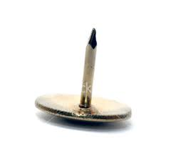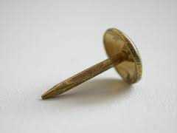
Pin up or Pin down

Problem
Here are two possible investigation questions. Choose one to investigate:
- I wonder what the probability of the pin landing pin up is?
- I wonder what the probability of the pin landing pin down is?

I predict that the probability of …

I made this prediction because …

Plan
My sample space or outcomes are

Number of trials =

The reason I choose this number of trials is because

The results will be recorded

List the steps needed to run the simulation:

Data
Carry out your experiment and record your data in a suitable format.

Outcome | Tally | Frequency | Relative Frequency
Pin Up
Pin Down

Analysis
Draw both a frequency and relative frequency bar graph

Mode =

I notice that the most common result is

Conclusion
From my simulation the estimated probability of

My prediction was correct / not correct

Practice Assessment 1
You are investigating a dice game.
Instructions for the game:
• The game is played in pairs.
- Two dice are rolled and the numbers facing up are added. This sum is recorded.
- Player 1 wins if the sum of the two dice is 2, 3, 4, or 5
- Player 2 wins if the sum of the two dice is 9, 10, 11 or 12

Pose an investigative question to explore that is related to this game

Make a prediction. Write down what you think your expected results might be, and explain why.

Plan
Plan an experiment to answer your question.
Discuss and define the set of possible outcomes

Identify and justify the number of trials

Explain how you will record your results

List the steps needed to perform your experiment

Data
Carry out your experiment and record your data in a suitable format.

Draw at least two appropriate displays, including the experimental probability distribution, that show different features of the data in relation to the investigative question.

Calculate appropriate statistics from the data

Comment on patterns of the distribution (such as shape, center, spread).

Conclusion
Write a conclusion about your findings that answers your investigative question and provides supporting evidence for this answer.

Extra for Excellence

Problem
When posing an investigation question, we want to have an insightful question, that allows for a more detailed explanation.

For example:
We could investigate the distribution (this covers all possible outcomes, not just one single outcome).

Plan
When planning your simulation, think about what conditions you need to control in order for each simulation to be fair and consistent.

For example:
When rolling a die, I need to think about how I hold the die, what distance above the desk I release it from, the surface I’m releasing it on etc. I want this to be the same every time I do a simulation.

Example:
I will hold the die about 30cm above a desk and release it by having my hand facing downwards and opening it up so it drops. I will hold my hand above the center of the desk, so that it is not likely to drop onto the floor and therefore each roll of the die will be consistent. By using the same procedure each time, I am minimising the variation between each simulation, which increases my accuracy.
I also rolled the die onto a smooth surface so that it would be clear which side of the die was facing upwards.

Analysis

Long run frequency
This looks at how the frequency changes as you run more and more simulations. The first few times you run a simulation the probability varies, but as we include more and more data into our estimate of the probability, the accuracy of this increases, and the estimated probability gets closer and closer to the true probability.

$$\text{P}\left(\text{Event}\right)\text{=}\frac{\text{Number of events}}{\text{sample size }\left(\text{or number or trials}\right)}$$

Example:
Here is a long-run frequency graph for tossing a coin and recording the number of heads. There are two lines, which shows two experiments.
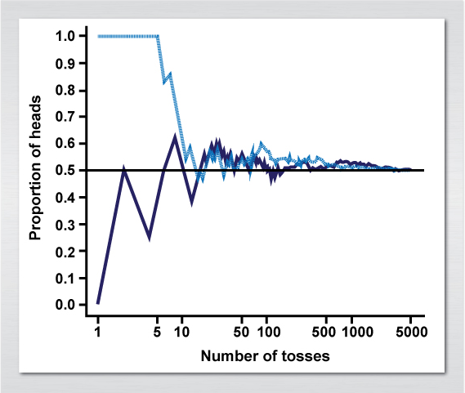
Notice that as the number of tosses (our sample size) gets bigger and bigger, the probability of a head gets closer and closer to 0.5 or 50%.

Example:
We want to toss a coin, and find the long-run frequency of getting a head.
$$\text{P}\left(\text{Heads}\right)\text{=}\frac{\text{Number of heads}}{\text{Number of times the coin has been tossed}}$$

Flip | Result | H's so far | Working out probability | P(Head)
1 | T | 0 | $$0/1$$ | 0.00
2 | H | 1 | $$1/2$$ | 0.50
3 | T | 1 | $$1/3$$ | 0.33
4 | T | 1 | $$1/4$$ | 0.25
5 | H | 2 | $$2/5$$ | 0.40
6 | T | 2 | $$2/6$$ | 0.33
7 | T | 2 | $$2/7$$ | 0.29
8 | T | 2 | $$2/8$$ | 0.25
9 | H | 3 | $$3/9$$ | 0.33
10 | T | 3 | $$3/{10}$$ | 0.30
11 | H | 4 | $$4/{11}$$ | 0.36
12 | H | 5 | $$5/{12}$$ | 0.42
13 | T | 5 | $$5/{13}$$ | 0.38
14 | H | 6 | $$6/{14}$$ | 0.43
15 | T | 6 | $$6/{15}$$ | 0.40
16 | H | 7 | $$7/{16}$$ | 0.44

Here is a graph of the first 10 flips. Notice that the relative frequency is on the y-axis, and the number of flips is on the x-axis. Also notice that there is a lot of variation in the probability.
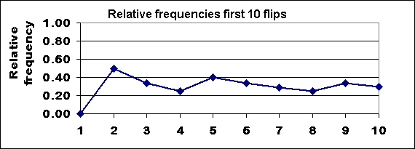

Here is a graph of the first 100 flips. Notice how the probability is starting to flatten out.
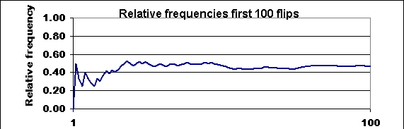

Here is a graph of the first 500 flips. Notice how the probability is getting quite stable now?
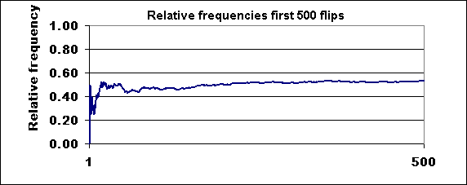

So the bigger the sample size, the more accurate our probability estimate is.

Exercise:
We want to estimate the long-run-probability of getting an EVEN number on a die.
Roll a die at least 20 times, calculating the long run relative frequency for an EVEN number.
Roll | Result | # Even so far | P(Even)
1
2
3
4
5
6
7
8
9
10
11
12
13
14
15
16
17
18
19
20

Number of rolls
Relative Frequency

Conclusion
For Excellence there are three parts we can add.
- We want to compare our results with our prediction, and try to explain and connect these together.
- We want to reflect on the simulation and think about what we could improve on if we repeated the simulation.
- We want to discuss sampling variability.

Example Prediction comparison:
When tossing the drawing Pin, I predicted that it would land Pin Up 30% of the time. In my simulation, I found that the probability of landing Pin Up was 38%. My prediction was lower than my simulation result, but in the same general region.
I think that the Pin landed up with this probability as the top of the pin is quite heavy and when we toss a pin it is more likely to drop to the bottom, landing Pin Up. There is also a much larger surface area, so if any of the head of the pin touches the surface when we toss it, it is very hard for the pin to turn around and go against the momentum which will be pushing the head of the pin down.

Example Reflection:
When I was tossing my drawing pin, I tried to toss the pin in the same way each time. But I could improve my method of tossing further, which would increase my accuracy. For example, I could toss the pin by placing my hand on a structure, so that I always tossed from the same height above the desk.
I could also hold the pin in the exact same way for each simulation. For example, I could hold the pin with the head facing upwards between my finger and thumb, twisting my hand half a turn as I released the pin.

Sampling variability
If we look at the long-run-frequency chart, we want to look at how the spread of the data changes as the sample size increases.

On the graph below, I have added two lines – one at the top of the values, and the other at the bottom values.
Let’s look at the spread at the start, by looking at how wide the variation is. Then look at how wide the variation is as the same size increases.

Did you notice how at the start the two lines are further apart, and as the sample size gets bigger, these two lines get closer and close together?
That shows how with more information we are more accurate and precise in our estimate of the probability. As the sample size increases, the variation in our estimate reduces.

Exercise:
Complete the following sentence starters (think about the data, summary statistics such as the mode and median, and the estimated probability):
If I ran another simulation ….

If I had a larger number of trials …….

Practice Assessment 2
You are investigating a dice game.
Instructions for the game:
• The game is played in pairs.
- Two dice are rolled and the numbers facing up are subtracted. This difference is recorded.
- Player 1 wins if the difference between the two dice is 0, 1 or 2
- Player 2 wins if the difference between the two dice is 3, 4 or 5

Instructions
Problem
Pose an investigative question to explore that is related to this game

Make a prediction. Write down what you think your expected results might be, and explain why.

Plan
Plan an experiment to answer your question.
Discuss and define the set of possible outcomes

Identify and justify the number of trials

Explain how you will record your results

List the steps needed to perform your experiment

Data
Carry out your experiment and record your data in a suitable format.

Analysis
Draw at least two appropriate displays, including the experimental probability distribution, that show different features of the data in relation to the investigative question.

Calculate appropriate statistics from the data

Comment on patterns of the distribution (such as shape, center, spread).

Conclusion
Write a conclusion about your findings that answers your investigative question and provides supporting evidence for this answer.

Discuss sampling variation for your simulation

Discuss your prediction in relation to the experimental probability distribution

Reflect on your simulation, and discuss any changes or improvements you would make if you ran the simulation again.

Marking Grid

 | Achieved |  | Merit |  | Excellence
Problem | Appropriate investigative question |  | Appropriate investigative question |  | Insightful investigative question
Plan | Suitable plan with guidance |  | Suitable plan without guidance |  | Comprehensive plan without guidance
 | Describes the set of possible outcomes and chooses a sample size. |  | Gives reasons why specific plan elements were chosen. |  | Gives statistical reasons why specific plan elements were chosen.
Data | Gathers data as per the plan
Analysis | Creates at least two appropriate data displays, one of which is an experimental probability distribution.
 |  |  | Summary statistics (mean or median or mode)
 | Identifies at least two features or patterns of the data. |  | Two features or patterns identified in context
Conclusion | Answers the investigative question. |  | Conclusion justified,  Or  Reflection on simulation, Or  Reflection on prediction |  | In-depth reflection on the prediction,  Or  Full comparison of experimental and theoretical distributions
 |  |  |  |  | Statistical insight shown
 | All required |  | All required |  | All required

Next step

Further practice assessments will be available on Google Classroom. Please let your teacher know when you complete one, so that they can mark it and give you feedback.

Once the practice assessment on Google Classroom is complete, you will be able to start the real assessment. Your teacher will release this to you when you have had your practice assessment returned.

Good luck.

